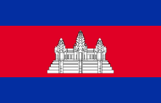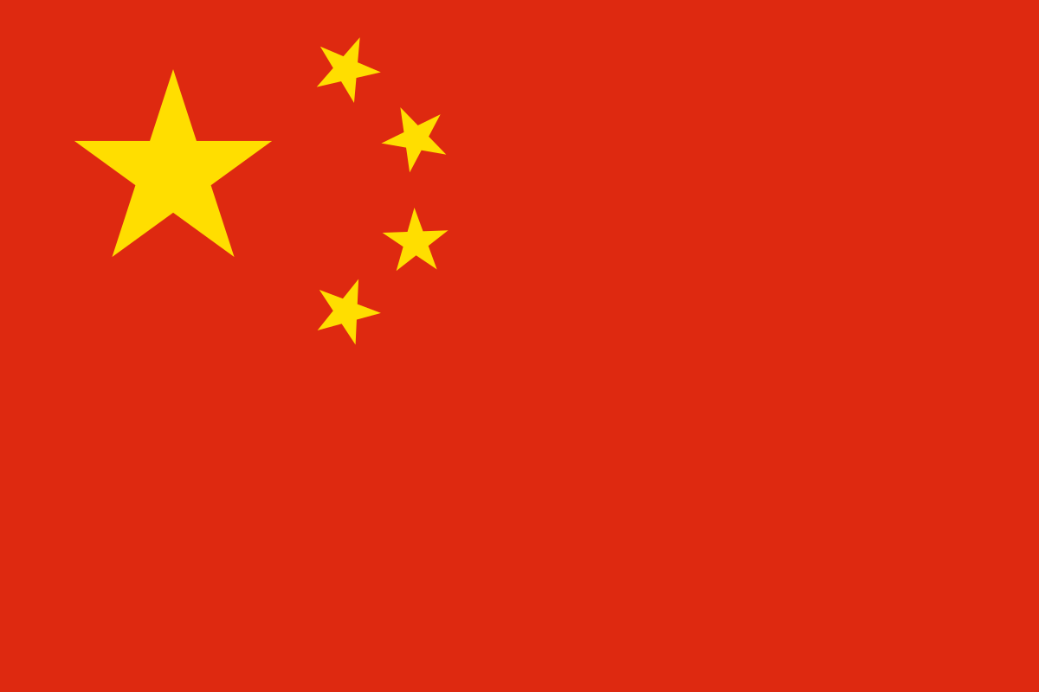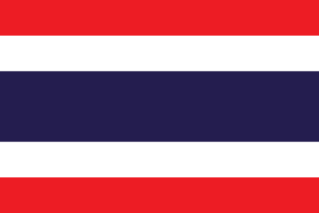

**VIETNAM 1 SFA THAILAND FUJIAN CHINA CAMBODIA KOREA GUANGDONG CHINA THAILAND PORT A&T NHA TRANG**

**LỊCH THI ĐẤU GIẢI VÔ ĐỊCH BÓNG ĐÁ CỰU CẦU THỦ QUỐC TẾ**

**THE INTERNATIONAL SENIOR FOOTBALL CHAMPIONSHIP – 2018**

**NHA TRANG City, VIETNAM *(From August 27th to September 01st, 2018)***

**SCHEDULE & MATCHUP**

|  |  |
| --- | --- |
| **GROUP A** | **GROUP B** |
| 1. **A&T NHATRANG – VIETNAM (Home team)** 2. **SFA THAILAND team** 3. **CAMBODIA team** 4. **PHÚC KIẾN - CHINA team** | 1. **VIETNAM 1 team** 2. **PORT OF THAILAND team** 3. **QUẢNG ĐÔNG – CHINA team** 4. **S&A SAIGON team** |
| **WOLDY FOOTBALL CLUB JUNG-GU INCHEON KOREA team** | |

|  |  |  |  |  |  |
| --- | --- | --- | --- | --- | --- |
| **NGÀY**  *(DATE)* | **GIỜ**  *(TIME)* | **SỐ TRẬN**  **N0 of matches** | **CHƯƠNG TRÌNH & TRẬN ĐẤU**  *(SCHEDULE & MATCHUP)* | **ĐỊA ĐIỂM**  *(STADIUM)* | **BẢNG**  *(GROUP)* |
| 27/08/2018  *August 27th, 2018* | **17h30** | **Tiệc Welcome *(Welcome Party)*** | | **Nha Yen Restaurant** | |
| 28/08/2018  *August 28th, 2018* | **14h00** | **Khai mạc giải (*OPENING CELEBRATION)*** | | ***(19/8 Nha Trang Stadium)*** |  |
| 14h30 | 01 | SFA THAILAND – CAMBODIA | A |
| 16h30 | 02 | A&T NHA TRANG -  **FUJIAN** CHINA | A |
| 18h30 | 03 | VIETNAM 1 - THAILAND PORT | B |
| 16h00 | 04 | S&A SAIGON - **GUANGDONG CHINA** | ***Nguyen Khuyen*** | B |
| 29/08/2018  *August 29th, 2018* | 14h30 | 05 | THAILAND PORT - S&A SAIGON | ***(19/8 Nha Trang Stadium)*** | B |
| 16h30 | 06 | VIETNAM 1 –  **GUANGDONG CHINA** | B |
| 18h30 | 07 | A&T NHA TRANG - CAMBODIA | A |
| 15h30 | 08 | SFA THAILAND - FUJIAN CHINA | ***Nguyen Khuyen*** | A |
| 30/08/2018 *August 30th, 2018* | 14h30 | 09 | THAILAND PORT - **GUANGDONG CHINA** | ***(19/8 Nha Trang Stadium)*** | A |
| 16h30 | 10 | VIETNAM 1 - S&A SAIGON | B |
| 18h30 | 11 | A&T NHA TRANG - SFA THAILAND | A |
| 14h00 | **Friendly Match** | **KOREA – DBS VIETNAM** | ***Nguyen Khuyen Stadium*** |  |
| 15h30 | 12 | CAMBODIA -  **FUJIAN** CHINA | B |
| *31/08/2018*  *August 31st, 2018* | 14h30 | 13 | First B – Second A **(01)** | ***(19/8 Nha Trang Stadium)*** | SEMI FINAL |
| 16h30 | 14 | First A - Second B **(02)** |
| 14h00 | 15 | 03rd place of A – 03rd place of B | ***Nguyen Khuyen Stadium*** | RANK 5 - 6 |
| 16h00 | 16 | 04th place of A - 04th place of B | RANK 7 - 8 |
| **19h00** | **GALA DINNER PARTY** | | **ANA MARINA** | |
| 01/09/2018  *September 01st, 2018* | 14h00 | **Friendly match** | **Teams won of match 5-6 - KOREA** | ***(19/8 Nha Trang Stadium)*** |  |
| 15h30 | 17 | **Lost Semi final 1 – Lost Semi Final 2** | RANK 3 - 4 |
| 17h30 | 18 | **CHAMPION** | FINAL |
| **19h30** | **Awards** | |  |
| 02/09/2018  *September 02nd,2018* |  | ***Transfer to airport. Thanks all*** | | | |

* **sponsored by** *:*

